 |  | Mathematics Essentials 2016  Unit 3/4 Test 2  Task Weighting: 6%
Student Name:

Time Allowed: 55 Minutes Total Marks: 42

Calculators and files are allowed in this test.
Answer all of the following questions. Show all working where appropriate to maximise marks.

Question 1 (4 marks: 1, 1, 1, 1)
Circle the correct answer in each of the following multiple choice questions.

The three sides of a right-angled triangle measure 40 m, 41 m and 9 m. The length of the hypotenuse is:

(i) 9 m (ii) 40 m (ii) 41 m (iv) none of these
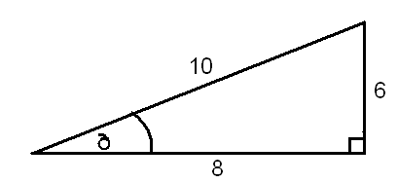

- In relation to the angle, which is the opposite side?

(i) 10 (ii) 8 (iii) 6 (iv) none of these

- A map has a scale of 1 : 5000. 5cm on the map is equal to how far in real life?

(i) 5000 cm (ii) 2500 cm (iii) 25 m (iv) 250 m

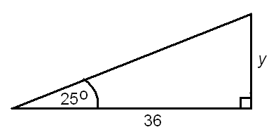

- The value for y in the diagram is given by:

(i) 36 x tan 25^{O} (ii) 36 x cos 25^{O} (iii) (iv)
36__
tan 25^{O}
36__
sin 25^{O}

Question 2 (6 marks: 3, 2, 1)
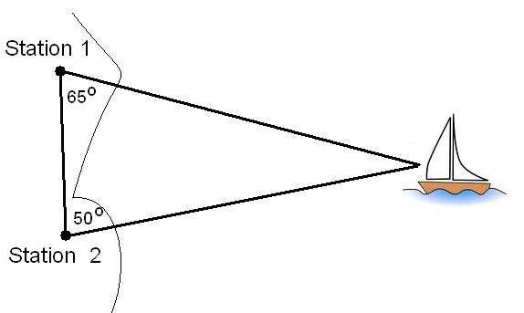
- Using a ruler and a protractor, make an accurate scale drawing of the diagram on the right. The stations are 20 km apart.
Use scale 1cm = 2km

- Use your scale drawing to calculate how far the boat is from Station 1

- State 1cm = 2 km as a scale with no units. i.e 1 :

Question 3 (7 marks: 2, 2, 3)

For each of the triangles below, find the value of the third side, giving your answer correct to 1 decimal place.

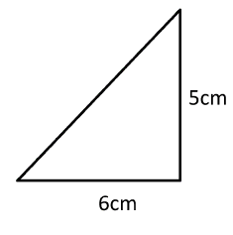

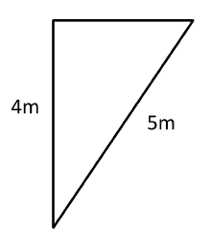

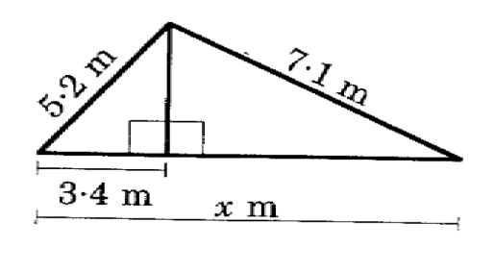

Question 4 (3 marks)
Find the value of x, giving your answer correct to 1 decimal place.

x
23 m

35⁰

Question 5 (3 marks)
Find the size of the angle marked x, correct to the nearest degree.

8.7 m

x

6.2 m

Question 6 (3 marks)
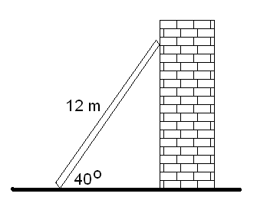
A ladder 12 m long leans against a wall. If it forms an angle of 40⁰ with the ground, how far is the bottom of the ladder away from the wall?

Question 7 (4 marks)

Consider the diagram below. Indicate which view is given in each of the three 2D diagrams for the first shape and then draw the top, front and side views of the next shape.

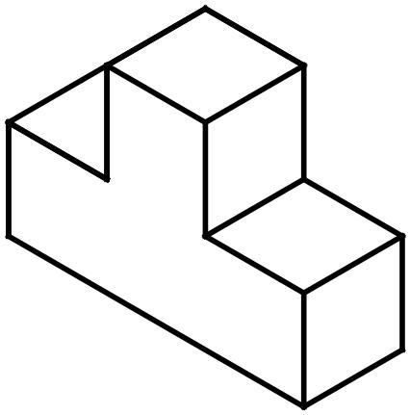  Top  Front  Side | View From ____________  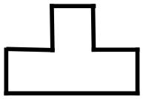 | View From ____________  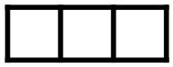 | View From ____________  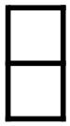
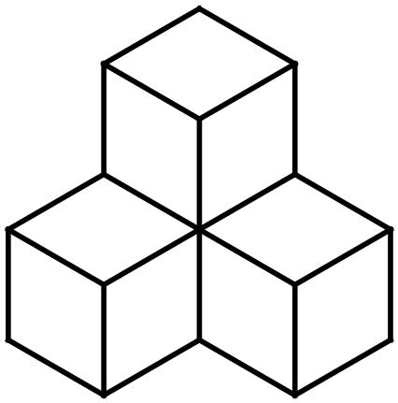 | View from top | View from Front | View from Side

Question 8 (6 marks: 2, 2, 2)
Draw and name the following shapes, according to the descriptions given below:

Description | Name | Drawing
(a) A 3D shape with 6 faces,
all of which are the
same size and shape.
(b) A 3D shape that is made
up of 5 faces – 2
triangles and 3
rectangles.
(c) A 3D shape which has a single curved edge, a
vertex and a circle base.

Question 9 (6 marks: 2, 2)
Ryan is sitting in a park and looks towards the top of a 120 m tall tower at an angle of elevation of 31⁰.

- Draw and label a diagram of this situation.

- How far is Ryan sitting from the base of the tower, to the nearest metre?

END OF TEST

